Exercise II.

- Assuming that the diodes in the following circuits are ideal, find the values of the labeled currents and voltages 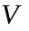.

2. Assuming OPA to be ideal, find the transfer function 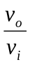 and the feedback factor 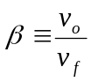.

3. A silicon junction diode with 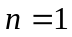 has 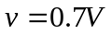, 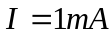 at 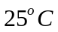. Find the voltage drop at 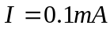and 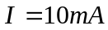.

4. The following Bode diagram illustrates the frequency response of a low pass filter. Find the value of DC gain K and –3 dB frequency.
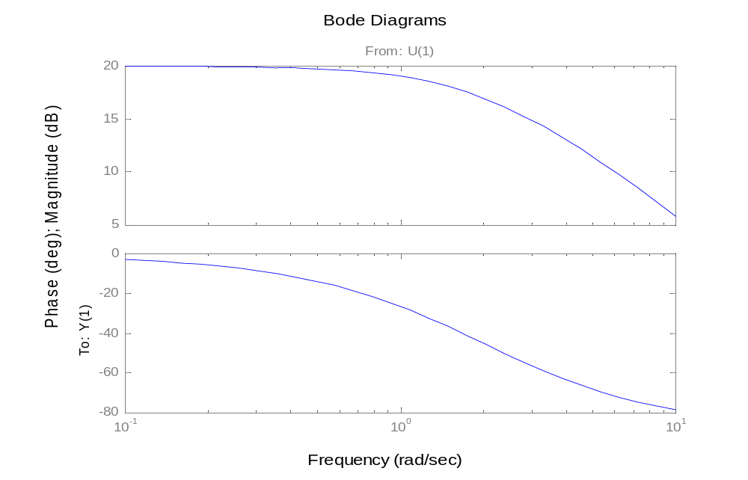
5. The circuit of Fig. 5. used an OPA that is ideal except for having a finite gain . Find the transfer function.

Fig. 5.

6. For the circuit shown in Fig. 6, express 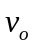 as a function of 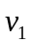 and 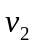. What is the input resistance seen by alone? By alone? By a source connected between the two input terminals?

Fig. 6

7. What are the equivalent circuit and the ideal properties of an ideal OPA?

8. What are the piecewise-linear model of the diode forward characteristics and its equivalent circuit representation?

9. Assuming the diodes to be ideal, describe the transfer characteristic of the circuit shown in Fig. 9.

Fig 9.

10. Show that the circuit shown in Fig. 10 has a STC low-pass transfer function, find the DC gain and the –3 dB frequency.

Fig 10

11. Show that the circuit shown in Fig. 11 has an STC high-pass transfer function, find the DC gain and the –3 dB frequency. Sketch and label it’s Bode plot.

Fig. 11

12. Fig. 12 shows a weighted summer. Show that the transfer function is given by 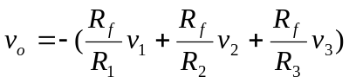

Fig. 12

13. Consider the circuit in Fig. 13 with 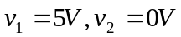, and assume the diode resistance 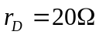 and the diode voltage 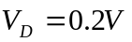. Find the value of output voltage .

Fig. 13

14. Derive the transfer function 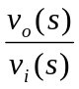 of the circuit in Fig. 14. and show that the circuit has a STC high-pass transfer property. Find the DC gain and the –3 dB frequency.

Fig. 14

15. Fig. 15 shows a popular circuit for an instrumentation amplifier. Derive the output function 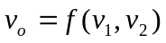 for the case the 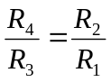.


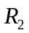
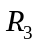
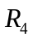

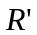
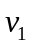
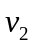

Fig. 15

16. Find the values of and in the circuits shown in Fig. 16.

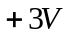
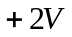
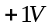
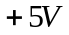

Fig. 16

17. Find the input resistance 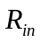 of the circuit in Fig. 17.

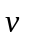

Fig. 17

